RV32IM 5-Stage Pipelined CPU Architecture Specification V3 (Harvard IBUS/DBUS/SBUS)

1. Design Goals and Scope

What this CPU supports
- ISA: RISC-V RV32I base integer instruction set plus the RV32M integer multiply/divide extension.
- Pipeline: Classic 5-stage in-order pipeline (Instruction Fetch, Instruction Decode, Execute, Memory, Writeback).
- Hazard Handling: Full data forwarding, load-use hazard detection (stalling), and control hazard handling (flushing).
- Phase 1 Subset: ADD, SUB, AND, OR, XOR, ADDI, ANDI, ORI, XORI, LW, SW, BEQ, BNE, JAL, LUI, plus RV32M instructions MUL, MULH, MULHSU, MULHU, DIV, DIVU, REM, REMU.

RV32M Instructions
RV32M Instruction | Result | Signedness | Notes
MUL | low 32 bits of rs1 * rs2 | signed x signed | Writes rd
MULH | high 32 bits of rs1 * rs2 | signed x signed | Writes rd
MULHSU | high 32 bits of rs1 * rs2 | signed x unsigned | Writes rd
MULHU | high 32 bits of rs1 * rs2 | unsigned x unsigned | Writes rd
DIV | quotient rs1 / rs2 | signed | RISC-V divide-by-zero and overflow behavior
DIVU | quotient rs1 / rs2 | unsigned | Divide-by-zero result is all 1s
REM | remainder rs1 % rs2 | signed | Divide-by-zero result is dividend
REMU | remainder rs1 % rs2 | unsigned | Divide-by-zero result is dividend

What is intentionally excluded
- Exceptions, interrupts, and CSRs (Control and Status Registers).
- Cache memory and MMU (Memory Management Unit).
- Privilege modes (Machine, Supervisor, User).
- Instruction sets beyond RV32IM are excluded: no floating-point, atomics, compressed instructions, privilege modes, or vector extensions.

Key assumptions
- 32-bit Architecture: All registers, datapaths, and memory addresses are 32 bits wide.
- Harvard Architecture: The core exposes three logically independent external buses: IBUS for instruction fetch, DBUS for normal data memory load/store traffic, and SBUS for system/MMIO/debug access. IBUS and DBUS preserve the Harvard separation between instruction and data paths, while SBUS keeps memory-mapped peripherals out of the normal data-memory timing path.
- Memory Model: For the first iteration, memory reads are assumed to be combinational (asynchronous) for simplicity, while writes are synchronous.

2. High-Level Architecture Overview
The CPU follows the classic RISC 5-stage pipeline. The IF stage talks only to IBUS, while the MEM stage routes load/store requests through a Load Store Unit (LSU) to either DBUS or SBUS based on the physical address map. Bus ready signals participate in the same global stall policy as load-use, RV32M multi-cycle, and control-hazard events.
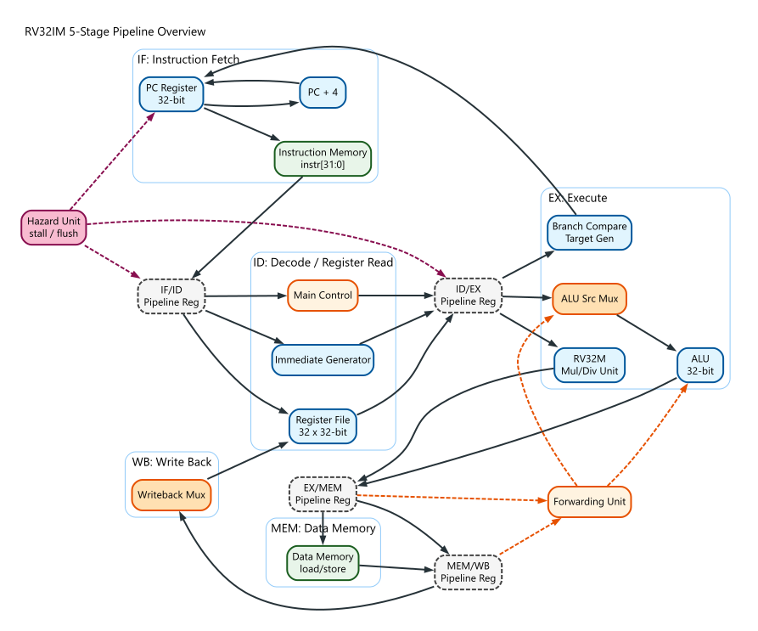
Figure AI-01: RV32IM five-stage pipeline overview.

2.1 Harvard Bus Architecture: IBUS, DBUS, and SBUS
IBUS is owned by the IF stage and carries instruction fetch requests. It should not be reused for data loads, stores, or MMIO, even when instruction and data memories share an implementation behind the integration boundary.
DBUS is owned by the MEM-stage LSU for ordinary data-memory accesses. Loads and stores targeting SRAM, data cache, or main data memory use DBUS.
SBUS is owned by the MEM-stage LSU for memory-mapped system accesses such as timer, UART, GPIO, debug windows, or implementation-specific control/status registers outside the base RV32IM architectural state.
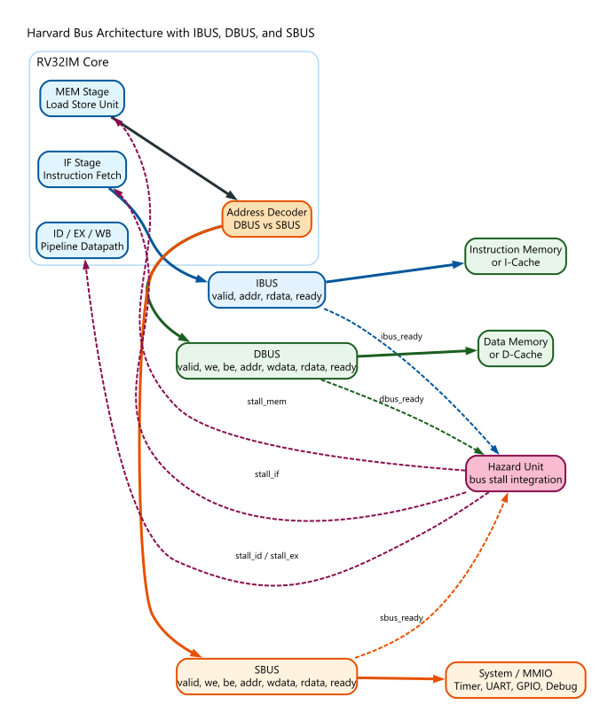
Figure AI-BUS-01: Harvard architecture with IBUS, DBUS, and SBUS.

3. Pipeline Stage-by-Stage Specification

Stage 1: Instruction Fetch (IF)
- Main function: Fetch the next instruction from memory and update the Program Counter (PC).
- Inputs: Current PC, Branch Target Address, PC selection signal, ibus_ready.
- Outputs: Fetched Instruction, PC, PC+4, ibus_valid, ibus_addr.
- Key logic: An adder calculates PC+4, a multiplexer selects PC+4 or branch/jump target, and the IF-stage bus wrapper drives IBUS. If ibus_ready is low while ibus_valid is asserted, PC and IF/ID are held.
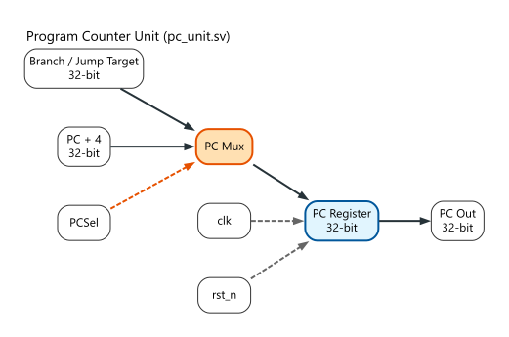
Figure AI-02: Program counter update path in pc_unit.sv.

Stage 2: Instruction Decode / Register Read (ID)
- Main function: Decode the instruction to generate control signals, read operands from the Register File, and extract/extend the immediate value.
- Inputs: Fetched Instruction, PC, Writeback Data, Writeback Address, RegWrite signal.
- Outputs: rs1_data, rs2_data, immediate, PC, rd_addr, rs1_addr, rs2_addr, control signals.
- Key logic: Main Decoder, ALU Decoder, Immediate Generator, Hazard Detection Unit.
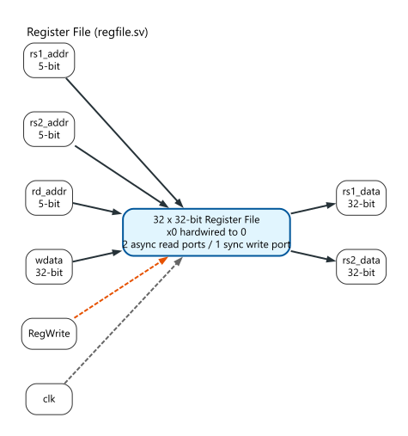
Figure AI-03: Register file interface in regfile.sv.

Stage 3: Execute / Address Calculation (EX)
- Main function: Perform arithmetic/logic operations, RV32M multiply/divide operations, calculate memory addresses for load/stores, and evaluate branch conditions and targets.
- Inputs: rs1_data, rs2_data, immediate, PC, control signals, forwarding data.
- Outputs: ALU result, write data (rs2_data), branch target, branch taken signal, rd_addr, control signals.
- Key logic: ALU, RV32M multiply/divide unit, Forwarding Multiplexers, Branch Adder, Branch Condition Evaluator.
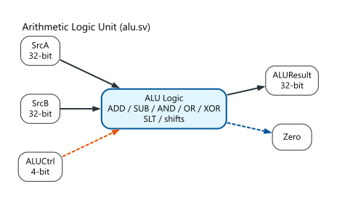
Figure AI-04: ALU datapath and control interface in alu.sv.
RV32M Execute Strategy: The M extension is implemented in the EX stage as a separate multiply/divide unit selected by the ALU control decoder. Multiplication may be implemented as a single-cycle combinational block for the first version. If timing closure requires it, the same interface can be backed by a multi-cycle or pipelined multiplier. Division and remainder are treated as multi-cycle EX operations. While div_busy is asserted, PC and IF/ID are held, ID/EX is held, and younger pipeline state is not advanced into EX. The multiply/divide unit interface is: valid, op[2:0], rs1, rs2, ready, result[31:0]. A result becomes visible to the normal EX/MEM pipeline register only when ready is asserted. Flush priority is higher than a pending multi-cycle operation. If a taken branch or jump flushes the instruction owning the M operation, the unit must cancel or ignore the stale result.
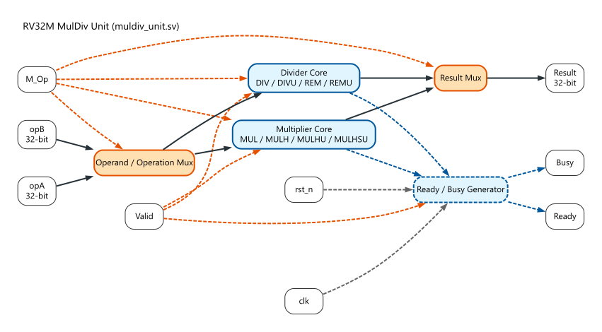
Figure AI-05: RV32M multiply/divide execution unit in muldiv_unit.sv.

Stage 4: Memory Access (MEM)
- Main function: Read from or write to memory through the LSU. Ordinary data-memory addresses use DBUS; system/MMIO/debug addresses use SBUS.
- Inputs: ALU result (address), write data, memory control signals, dbus_ready, sbus_ready.
- Outputs: Load data selected from DBUS or SBUS, ALU result (passed through), rd_addr, control signals, bus stall request.
- Key logic: Load Store Unit, byte-enable generation, address decoder, DBUS/SBUS request routing, and read-data mux.

Stage 5: Write Back (WB)
- Main function: Write the final result back to the Register File.
- Inputs: Memory read data, ALU result, PC+4 (for JAL), writeback control signals.
- Outputs: Final write data to Register File.
- Key logic: Writeback Multiplexer.

4. Pipeline Register Definition

IF/ID Register
Signal Name | Width | Meaning | Produced By | Consumed By
PC | 32 | Address of current instruction | IF | ID, EX (Branch target)
Instruction | 32 | Fetched instruction | IF | ID
PC_Plus4 | 32 | Next sequential address | IF | WB (JAL)

ID/EX Register
Signal Name | Width | Meaning | Produced By | Consumed By
PC | 32 | Address of current instruction | IF | EX (Branch calc)
rs1_data | 32 | Data from source register 1 | ID (RegFile) | EX (ALU)
rs2_data | 32 | Data from source register 2 | ID (RegFile) | EX (ALU, MemWrite)
imm | 32 | Sign-extended immediate | ID (ImmGen) | EX (ALU, Branch)
rs1_addr | 5 | Source 1 address | ID | EX (Forwarding logic)
rs2_addr | 5 | Source 2 address | ID | EX (Forwarding logic)
rd_addr | 5 | Destination address | ID | WB (RegFile write)
Ctrl_WB | 2 | RegWrite, WBSel | ID (Decoder) | WB
Ctrl_MEM | 2 | MemRead, MemWrite | ID (Decoder) | MEM
Ctrl_EX | 4 | ALUSrc, ALUOp, Branch, Jump | ID (Decoder) | EX

EX/MEM Register
Signal Name | Width | Meaning | Produced By | Consumed By
ALU_Out | 32 | Result of ALU / Mem Addr | EX | MEM, WB
Store_Data | 32 | Data to write to memory (rs2) | EX | MEM
rd_addr | 5 | Destination address | ID | WB
Ctrl_WB | 2 | RegWrite, WBSel | ID | WB
Ctrl_MEM | 2 | MemRead, MemWrite | ID | MEM

MEM/WB Register
Signal Name | Width | Meaning | Produced By | Consumed By
Mem_Data | 32 | Data read from memory | MEM | WB
ALU_Out | 32 | Result of ALU | EX | WB
rd_addr | 5 | Destination address | ID | WB (RegFile)
Ctrl_WB | 2 | RegWrite, WBSel | ID | WB

5. Datapath Description
- PC Update: The PC register is updated on every clock edge. A multiplexer selects either PC+4 (normal execution) or BranchTarget (if a branch is taken or jump occurs).
- Instruction Fetch: The PC is used as an address to read the Instruction Memory.
- Register Operands: The rs1 and rs2 fields (bits 19-15 and 24-20) are fed directly to the Register File read ports.
- Immediate Generation: The ImmGen module extracts bits from the instruction based on the opcode and sign-extends them to 32 bits.
- ALU Operands:
  - Operand A: Comes from a 3-to-1 mux selecting between rs1_data, EX/MEM forwarding data, or MEM/WB forwarding data.
  - Operand B: Comes from a similar 3-to-1 forwarding mux. This forwarded value is then passed through a 2-to-1 ALUSrc mux, which selects between the register data and the immediate value.
- Memory Address: The ALU performs rs1 + imm for loads and stores. The output of the ALU is wired directly to the Data Memory address port.
- Load/Store Data: For SW, the forwarded rs2 data is passed into the EX/MEM register and then to the Data Memory write data port. For LW, data comes out of the memory read port.
- Writeback Data: A multiplexer (WBSel) chooses between ALU_Out, Mem_Data, and PC+4 (for JAL), sending the result to the Register File's write data port. Mem_Data is the LSU read-data result after DBUS/SBUS selection.
IBUS Datapath: The PC value drives ibus_addr during IF. ibus_rdata is captured into IF/ID only when ibus_ready is high or the integration ties ibus_ready to 1 for a zero-wait-state instruction memory.
DBUS/SBUS Datapath: The EX-stage ALU produces the effective address. In MEM, the LSU decodes that address, drives exactly one of DBUS or SBUS, and returns the selected read data to MEM/WB.
Bus Stall Datapath: A pending IBUS, DBUS, or SBUS request with ready low freezes the affected pipeline stages. No younger instruction may observe a partially completed memory or system transaction.

6. Control Signal Architecture
Phase 1 Control Signal Table
WBSel: 00 = ALU, 01 = MemData, 10 = PC+4
MulDivOp: selects MUL, MULH, MULHSU, MULHU, DIV, DIVU, REM, or REMU
MulDiv: 1 = instruction uses the RV32M multiply/divide unit
IBusStall: asserted when ibus_valid is high and ibus_ready is low.
DBusStall: asserted when dbus_valid is high and dbus_ready is low.
SBusStall: asserted when sbus_valid is high and sbus_ready is low.
MemUseSBus: generated by the LSU address decoder; selects SBUS read data and SBUS ready for the MEM-stage transaction.
ALUSrc: 0 = rs2, 1 = imm
Branch: 1 = is a branch instruction
Jump: 1 = is a jump instruction
Instruction | RegWrite | MemRead | MemWrite | WBSel | ALUSrc | ALUOp (2b) | Branch | Jump | Imm Type
ADD/SUB/etc | 1 | 0 | 0 | 00 | 0 | 10 (R-Type) | 0 | 0 | None
ADDI/etc | 1 | 0 | 0 | 00 | 1 | 11 (I-Type) | 0 | 0 | I-Type
LW | 1 | 1 | 0 | 01 | 1 | 00 (ADD) | 0 | 0 | I-Type
SW | 0 | 0 | 1 | XX | 1 | 00 (ADD) | 0 | 0 | S-Type
BEQ/BNE | 0 | 0 | 0 | XX | 0 | 01 (SUB) | 1 | 0 | B-Type
JAL | 1 | 0 | 0 | 10 | X | XX | 0 | 1 | J-Type
LUI | 1 | 0 | 0 | 00 | 1 | 10 (LUI) | 0 | 0 | U-Type
RV32M | 1 | 0 | 0 | 00 | 0 | M-Type | 0 | 0 | None

7. Instruction Decode Strategy
- Main Decoder: Takes the 7-bit opcode and generates all main control signals (RegWrite, MemRead, MemWrite, WBSel, ALUSrc, Branch, Jump) and a 2-bit ALUOp.
- ALU Decoder: Takes the 2-bit ALUOp, the 3-bit funct3, and the 7-bit funct7 (specifically bit 30) to generate a 4-bit ALUCtrl signal that tells the ALU exactly what to do.
- RV32M Decode: opcode 0110011 with funct7=0000001 identifies M-extension R-type instructions. funct3 selects MUL=000, MULH=001, MULHSU=010, MULHU=011, DIV=100, DIVU=101, REM=110, REMU=111.

8. Immediate Generator Design
- I-Type (ADDI, LW): imm = { {20{inst[31]}}, inst[31:20] }
- S-Type (SW): imm = { {20{inst[31]}}, inst[31:25], inst[11:7] }
- B-Type (BEQ, BNE): imm = { {20{inst[31]}}, inst[7], inst[30:25], inst[11:8], 1'b0 }
- U-Type (LUI): imm = { inst[31:12], 12'b0 }
- J-Type (JAL): imm = { {12{inst[31]}}, inst[19:12], inst[20], inst[30:21], 1'b0 }

9. Branch and Jump Handling
- Resolution Stage: EX Stage. Resolving in EX is much cleaner for a first project, at the cost of a 2-cycle flush penalty instead of a 1-cycle penalty.
- Branch Condition: Evaluated in EX by checking the ALU zero flag.
- Target Calculation: An adder in the EX stage computes PC + imm.
- PC Selection Priority: If (Branch & ConditionMet) | Jump, select target. Otherwise, PC+4.
- Flushing: If branch taken, clear IF/ID and ID/EX registers.

9.1 RV32M Architectural Corner Cases
For DIV and REM, signed arithmetic follows the RISC-V M extension rules. Division by zero returns quotient 0xFFFF_FFFF for DIV/DIVU and returns the original dividend for REM/REMU. Signed overflow, defined as 0x8000_0000 / -1, returns quotient 0x8000_0000 and remainder 0. All M instructions write rd unless rd is x0. Writes to x0 are ignored, but the instruction still completes normally.

10. Data Hazard Handling

10.1 Forwarding
- EX/MEM to EX: If prior instruction writes to used register.
- MEM/WB to EX: If instruction two cycles ago writes to used register.
if (EX_MEM.RegWrite && (EX_MEM.rd != 0) && (EX_MEM.rd == ID_EX.rs1))
ForwardA = 2'b10; // Forward from EX/MEM
else if (MEM_WB.RegWrite && (MEM_WB.rd != 0) && (MEM_WB.rd == ID_EX.rs1))
ForwardA = 2'b01; // Forward from MEM/WB
else
ForwardA = 2'b00; // Normal from ID/EX

10.2 Load-Use Hazard & M-Use Hazard
- Stall Condition: if ID_EX.MemRead and ID_EX.rd matches a source register actually used by IF_ID, hold PC and IF/ID for one cycle and inject a bubble into ID/EX.
- Forwarding Priority: EX/MEM forwarding has priority over MEM/WB forwarding when both match the same source register.
- M-Use Hazard: if an RV32M operation is multi-cycle and its destination is needed by a younger instruction, hold younger stages until the M result is ready. Once ready, the result follows the same EX/MEM and MEM/WB forwarding priority as ALU results.

11. Control Hazard Handling
- Baseline: Assume branches are not taken.
- Flush: Send Flush signal to IF/ID and ID/EX if branch is taken.
- Priority Order: reset has highest priority, then flush, then multi-cycle EX stall, then MEM bus stall (DBUS/SBUS), then load-use stall, then IBUS fetch stall, then normal pipeline advance.
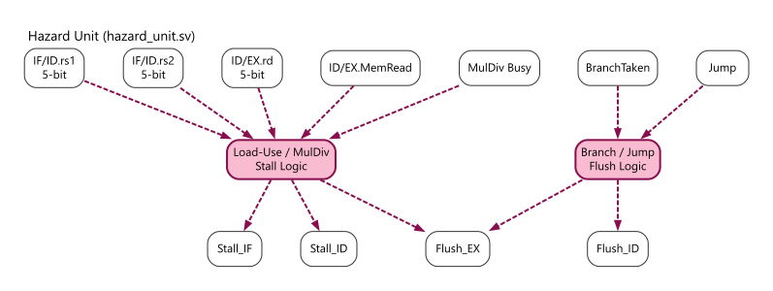
Figure AI-06: Hazard detection and pipeline control in hazard_unit.sv.

12. Register File Specification
- Dimensions: 32 registers, 32 bits wide.
- x0 Hardwired: Register 0 is strictly hardwired to 0.
- Ports: 2 asynchronous read ports, 1 synchronous write port.

13. Memory Interface Assumptions
Instruction Memory: Word-aligned and accessed through IBUS. A simple integration may tie ibus_ready high and return ibus_rdata combinationally; cache or external-memory integrations may deassert ibus_ready to stall fetch.
Data Memory: Accessed through DBUS for ordinary LW/SW traffic. DBUS supports byte enables so the same interface can later support byte/halfword instructions if the ISA subset grows.
System/MMIO: Accessed through SBUS. SBUS uses the same basic valid/we/be/address/data/ready handshake as DBUS, but targets peripherals and system blocks rather than normal data memory.

13.1 Bus Interface Signals
Bus | Producer | Consumer | Purpose | Stall source
IBUS | IF stage | Instruction memory or I-cache | Fetch 32-bit instructions | ibus_valid && !ibus_ready
DBUS | MEM-stage LSU | Data memory or D-cache | Normal LW/SW data access | dbus_valid && !dbus_ready
SBUS | MEM-stage LSU | MMIO/system/debug block | Peripheral and system access | sbus_valid && !sbus_ready

13.2 Address Map
Address range | Bus | Purpose
0x0000_0000 - 0x0FFF_FFFF | IBUS/DBUS | Instruction memory and optional shared main memory window
0x2000_0000 - 0x2FFF_FFFF | DBUS | Data SRAM or data cache window
0x4000_0000 - 0x4FFF_FFFF | SBUS | MMIO peripherals such as timer, UART, and GPIO
0xF000_0000 - 0xFFFF_FFFF | SBUS | Debug, test, or implementation-specific system region

13.3 Minimal Interface Contract
Signal | Width | IBUS | DBUS | SBUS | Meaning
valid | 1 | yes | yes | yes | Request is active
ready | 1 | yes | yes | yes | Target accepted/responded
addr | 32 | yes | yes | yes | Byte address
we | 1 | no | yes | yes | Write enable
be | 4 | no | yes | yes | Byte lane enables
wdata | 32 | no | yes | yes | Store/write data
rdata | 32 | yes | yes | yes | Read/fetch data
Only one of DBUS or SBUS may be valid for a single MEM-stage transaction.
Loads complete when the selected bus reports ready; stores complete when the selected bus accepts the write.
Instruction fetch may proceed independently from DBUS/SBUS unless the global hazard policy freezes the front end.

14. Module Decomposition Recommendation
- rv32im_core.sv: Top-level wrapper
- pc_unit.sv: PC register and target multiplexer
- regfile.sv: 32x32 register file
- decoder.sv: Main control decoder
- imm_gen.sv: Immediate extractor
- alu.sv: Single-cycle integer ALU
- alu_control.sv: ALU operation decoder
- muldiv_control.sv: Decodes funct3 for RV32M operations and manages multi-cycle busy/ready control
- muldiv_unit.sv: RV32M multiply/divide/remainder execution unit
- lsu.sv: Load Store Unit; generates byte enables, decodes DBUS vs SBUS, and selects returned load data
- bus_if.sv: Optional shared typedef/interface definitions for IBUS, DBUS, and SBUS signal bundles
- addr_decode.sv: Address map decoder used by the LSU to classify data-memory vs system/MMIO accesses
- hazard_unit.sv: Detects load-use stalls and branch flushes
- forwarding_unit.sv: Resolves data dependencies
- pipeline_regs.sv: Pipeline D-Flip-Flops
AI-friendly source note: editable Mermaid, Graphviz DOT, SVG, and PNG versions of these figures are stored under docs/architecture-diagrams/. The Harvard bus figure source is 06_harvard_ibus_dbus_sbus.mmd / dot/06_harvard_ibus_dbus_sbus.dot. Figure captions, stable figure IDs, and image alt text are intentionally explicit so downstream tools can parse the document structure.

15. Verification Plan
Bus-specific verification must cover fetch wait states, data-memory wait states, MMIO routing, and priority interactions with branch flushes and RV32M stalls.
Test category | Purpose | Example stimulus | Expected behavior
IBUS wait state | Verify fetch stall | ibus_ready low for 2 cycles | PC and IF/ID hold
DBUS load wait | Verify MEM bus stall | LW with delayed dbus_ready | Pipeline resumes with correct load data
SBUS MMIO write | Verify system routing | SW to 0x4000_0000 | sbus_valid asserted, dbus_valid low
DBUS/SBUS exclusion | Verify one-hot routing | Random load/store addresses | Never assert dbus_valid and sbus_valid together
Flush during bus wait | Verify priority | Taken branch while bus wait exists | Flush wins; stale younger transaction ignored or cancelled
Test Category | Purpose | Example Instruction Sequence | Expected Behavior
Basic ALU | Verify R/I types | ADDI x1, x0, 5; ADD x2, x1, x1 | x1=5, x2=10
Forwarding EX | Back-to-back dependency | ADDI x1, x0, 1; ADD x2, x1, x1 | Forward from EX/MEM
Load-Use Stall | LW immediately used | LW x1, 0(x0); ADD x2, x1, x1 | Pipeline stalls for 1 cycle
Branch Taken | Flush verification | BEQ x0, x0, target... | IF/ID and ID/EX flushed
RV32M Multiply | Verify MUL/MULH/MULHSU/MULHU | MUL x3,x1,x2; MULH x4,x1,x2 | Correct low/high product bits for signed and unsigned operands
RV32M Divide | Verify DIV/DIVU/REM/REMU | DIV x3,x1,x2; REM x4,x1,x2 | Correct quotient and remainder
Divide Corner Cases | Verify RISC-V-defined edge behavior | DIV x3,x1,x0; REM x4,x1,x0 | Divide-by-zero and signed overflow match spec
M Result Forwarding | Verify dependency after M instruction | MUL x1,x2,x3; ADD x4,x1,x5 | Dependent ADD receives forwarded product
Multi-cycle Stall | Verify divider pipeline hold | DIV x1,x2,x3; ADD x4,x5,x6 | Younger instruction does not enter EX until divider result is ready

16. Open Implementation Decisions
Before RTL freeze, choose whether MUL is single-cycle or multi-cycle, choose the divider algorithm and maximum latency, and decide whether unsupported instructions are NOPs or raise exceptions in later milestones.

